MINIMARKET CASHIER SYSTEM
FINAL SEMESTER EXAM PROJECT REPORT

(Prepared to fulfill the requirements for passing the Final Exam Semester 1)

By :
Eka Berlia Herni Rahmadani (25031554109)
Rizka Ulin Nuha (25031554145)
Welfee Putri Sukardi (25031554205)

Lecturer:
Hasanuddin Al-Habib, S.Si., M.Si
Siska Puspitaningsih, S.,Kom.M.Kom.

STUDY PROGRAM DATA SCIENCE
FACULTY OF MATHEMATICS AND NATURAL SCIENCES
STATE UNIVERSITY OF SURABAYA
2025

TABLE OF CONTENTS
CHAPTER1 2
INTRODUCTION 2
1.1 BACKGROUND 2
1.2 PROBLEM STATEMENT 3
1.3 OBJECTIVES 3
CHAPTER2 5
ANALYSIS AND DESIGN 5
2.1 APPLICATION NECESSITY ANALYSIS 5
2.2 FLOWCHART 6
CHAPTER3 7
IMPLEMENTATION 7
3.1 CODE EXPLANATION 6
3.2 APPLICATION SCREENSHOTS 54
CHAPTER4 60
ATTACHMENT 67
4.1 Embed File 67
REFERENCES 68

CHAPTER 1
INTRODUCTION

1.1 BACKGROUND
Minimarket Cashier System is a desktop based cashier application designed to assist minimarket operations in managing sales transactions, product inventory, and digital data recording. In today's digital era, the presence of computerized cashier systems has become a fundamental need for retail businesses, including minimarkets that are increasingly widespread in various locations as a response to the high demand from society for shopping convenience.
In minimarket operations, the cashier system plays a vital role as the center for transaction recording, product data management, inventory, and financial reporting. An efficient cashier system will greatly assist business owners in making appropriate business decisions based on accurately recorded transaction data. However, many small and medium scale minimarkets still use manual or semi manual systems that are prone to recording errors.
Some problems frequently encountered include: difficulty in tracking inventory in real time, slow transaction processes at the cashier, manual calculation errors, difficulty in creating sales reports, and the absence of well organized digital archives. These problems can have an impact on financial losses, decreased customer satisfaction due to long queues, and difficulty in conducting sales analysis for business development. Therefore, a digital cashier system solution is needed that can automate the transaction recording process, inventory management, and report generation.
As Data Science students who have an understanding of information technology and data management, we feel called to develop a desktop-based minimarket cashier application that can be a practical solution for small and medium-scale retail business practitioners. This application is designed with a user-friendly interface, equipped with complete features ranging from product management, shopping cart, to transaction recording and digital receipt generation. The application is developed using Python with Tkinter for the GUI and SQLite for database management, ensuring efficient and reliable performance.
Through the development of Minimarket Cashier System, we hope to make a real contribution in helping digitalize local retail businesses, improve minimarket operational efficiency, and provide a better shopping experience for consumers. In addition, this project also serves as a platform for us to apply the knowledge we have learned in lectures, especially in the fields of programming, databases, and information systems.

1.2 PROBLEM STATEMENT
Many small and medium scale minimarkets in Indonesia face significant challenges in managing their daily operations due to the reliance on manual or semi manual cashier systems. Traditional methods of recording transactions often lead to various operational issues that hinder business efficiency and growth. Manual cashier systems result in slow transaction speeds, creating long queues and reducing customer satisfaction, while also being highly prone to human errors in price calculations and total computations.
Without real time inventory tracking capabilities, minimarket owners struggle to monitor stock levels accurately, leading to overstocking or stockouts that affect sales and customer trust. The absence of organized digital archives makes it difficult to retrieve past transaction data, hindering the ability to analyze sales patterns and make informed business decisions. Additionally, generating sales reports manually is time-consuming and often inaccurate, making it challenging for business owners to evaluate performance and plan effective strategies.
These challenges not only impact the operational efficiency of minimarkets but also limit their potential for growth in an increasingly competitive retail market. To address these issues, there is a critical need for an accessible, user friendly digital cashier system that can automate key processes, reduce errors, and provide comprehensive data management capabilities for small and medium scale retail businesses.

1.3 OBJECTIVES
The purpose of making this minimarket cashier system includes:
1.3.1 To develop an intuitive desktop based cashier application that simplifies transaction processing for minimarket operations.
1.3.2 To create an efficient product and inventory management system with real time stock tracking and automated updates.
1.3.3 To implement automated sales recording and digital receipt generation that provides organized transaction archives.
1.3.4 To design a user friendly graphical interface that enables cashiers to operate the system with minimal training and technical knowledge.
CHAPTER 2
ANALYSIS AND DESIGN

2.1APPLICATION NECESSITY ANALYSIS
To create the Minimarket Cashier System, we conducted a thorough analysis of the reasons why this application is needed to provide a more efficient and reliable cashier experience. This analysis is divided into 2 parts:
2.1.1 Digital Transformation in Retail Business
- Reduce transaction time
- Eliminate calculation errors
- Real-time inventory tracking
- Digital records & data driven decisions
- Secure database management
2.1.2 Accessibility and Ease of Use for Small Scale Businesses
- User friendly GUI with Tkinter
- Minimal training needed
- Affordable (desktop based, no cloud subscription)
- Lightweight SQLite database
- CSV import for bulk entry
- Automated receipt generation

2.2 FLOWCHART
This project transforms a conventional manual cashier process into a digital application with an interactive graphical interface. The system automates product management, transaction calculations, and receipt generation to improve efficiency and reduce human error.
The flow diagram represents the transaction process from product selection and cart management to total calculation and checkout. This flow ensures a clear and structured operation of the cashier system from start to finish.

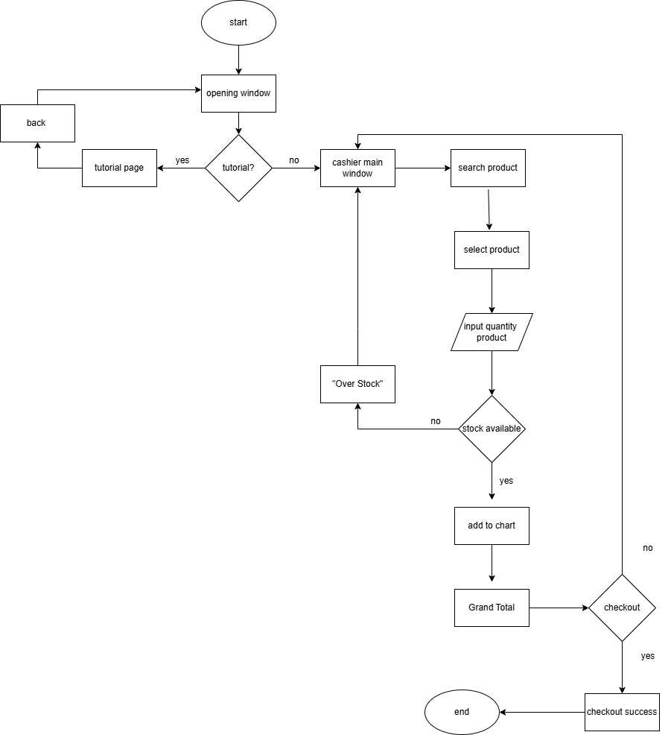

CHAPTER 3
IMPLEMENTATION

3.1 CODE EXPLANATION
The implementation of "Minimarket Cashier System" involves several modules and features, each designed to contribute to the overall functionality and user experience. Below is a detailed explanation of key sections of the code:

Figure 3.1 - Importing Libraries
Source: Personal documentation
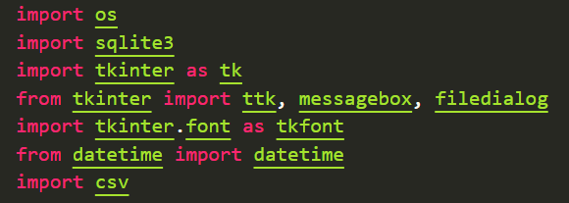
Importing Libraries:
- os: A built-in Python library for interacting with the operating system. Used for file path operations like getting the current directory, joining paths, and creating directories.
- sqlite3: A built-in Python library for database management. SQLite is a lightweight, file-based database that doesn't require a separate server, making it ideal for desktop applications.
- tkinter as tk: The standard Python interface to the Tk GUI toolkit. This library provides tools for creating graphical user interfaces including windows, frames, buttons, and labels. The as tk part creates an alias so we can write tk.Frame() instead of tkinter.Frame().
- ttk (from tkinter): A themed widget set that provides more modern-looking GUI components. Specifically used for the Treeview widget which displays tables.
- messagebox (from tkinter): Provides standard dialog boxes for user interaction such as warnings, errors, information messages, and yes/no confirmations.
- filedialog (from tkinter): Provides dialog boxes for opening and saving files. Used in this application for the CSV import feature.
- tkinter.font as tkfont: Used for measuring text width to implement the auto-adjust column feature in tables.
- datetime: A built-in Python library for handling dates and times. Used to timestamp transactions and format receipt filenames.
- csv: A built-in Python library for reading and writing CSV (Comma-Separated Values) files. Used for importing product data in bulk.
Purpose: These libraries form the foundation of the application, enabling database operations, GUI creation, file handling, and time management.

Figure 3.2 - Path Configuration
Source: Personal documentation
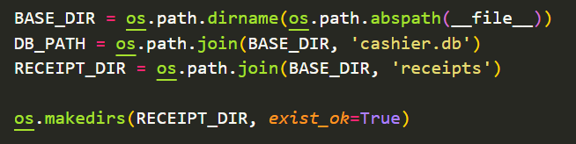
Setting Up File Paths:
This section establishes the directory structure for the application's files:
- BASE_DIR:
  - __file__ is a special variable that contains the path to the current Python script
  - os.path.abspath(__file__) converts it to an absolute path (e.g., C:\Users\Documents\kasir.py)
  - os.path.dirname() extracts just the directory portion (e.g., C:\Users\Documents)
  - This ensures all files are stored relative to where the program is located
- DB_PATH:
  - os.path.join() combines BASE_DIR with the filename 'cashier.db'
  - This creates a complete path like C:\Users\Documents\cashier.db
  - Using os.path.join() ensures the path works on Windows, Mac, and Linux
- RECEIPT_DIR:
  - Creates a path for a subdirectory named 'receipts'
  - All receipt files will be stored in this folder
  - Example result: C:\Users\Documents\receipts
- os.makedirs():
  - Creates the receipts folder if it doesn't already exist
  - The parameter exist_ok=True prevents errors if the folder is already there
  - Without this, the program would crash when trying to save a receipt if the folder doesn't exist
Purpose: This configuration ensures that the application stores all its data (database and receipts) in organized locations relative to the program file, making the application portable and easy to backup.

Figure 3.3 - Database Connection Function
Source: Personal documentation
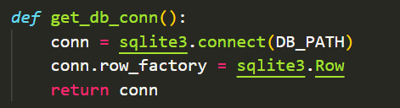
Database Connection Function:
This function establishes and configures a connection to the SQLite database:
- Function Definition:
  - def get_db_conn(): defines a function named "get_db_conn" (short for "get database connection")
  - No parameters are needed because DB_PATH is already defined globally
- Creating Connection:
  - sqlite3.connect(DB_PATH) opens or creates a connection to the SQLite database
  - If the database file doesn't exist, SQLite will automatically create it
  - The connection object conn is used to execute SQL commands
- Row Factory Configuration:
  - conn.row_factory = sqlite3.Row is a crucial configuration
  - Without this setting: Query results are returned as tuples like (1, 'E026', 'Mizone', 3000, 20)
  - With this setting: Results can be accessed by column name like row['name'], row['price']
  - This makes the code much more readable and maintainable
- Return Value:
  - Returns the configured connection object for use throughout the application
  - This connection will be stored and reused in the CashierApp class
Purpose: This function centralizes database connection logic and ensures consistent configuration. It's called whenever the application needs to interact with the database, making the code DRY (Don't Repeat Yourself).

Figure 3.4 - Database Initialization
Source: Personal documentation
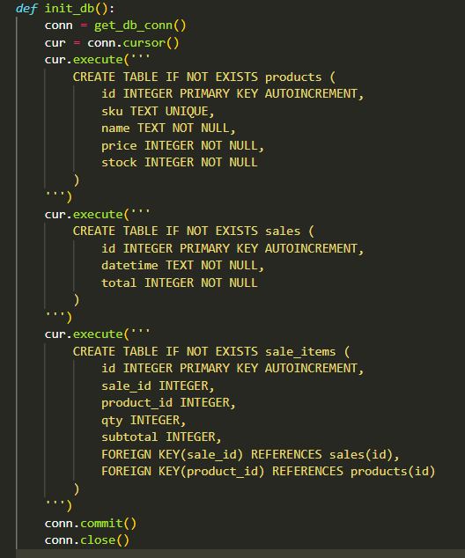
Database Table Creation:
This function creates the three main tables of the application's database structure:
- Function Setup:
  - conn = get_db_conn() opens a database connection
  - cur = conn.cursor() creates a cursor object for executing SQL commands
- A cursor is like a pointer that allows you to execute queries and fetch results
- Table 1 - products:
  - id: Primary key that automatically increments (1, 2, 3, ...)
  - sku: Product code (e.g., "E026") marked as UNIQUE to prevent duplicate codes
  - name: Product name (TEXT type for strings), NOT NULL means it's required
  - price: Product price (INTEGER type for whole numbers), required field
  - stock: Available stock quantity (INTEGER), required field
- Table 2 - sales:
  - id: Primary key for transaction identification
  - datetime: Timestamp of when the transaction occurred (stored as TEXT)
  - total: Total transaction amount after tax (INTEGER)
  - This table stores the "header" of each transaction
- Table 3 - sale_items:
  - id: Primary key for detail records
  - sale_id: Foreign key linking to the sales table
  - product_id: Foreign key linking to the products table
  - qty: Quantity of the product sold (INTEGER)
  - subtotal: Subtotal for this item (quantity × price)
  - This table stores the "details" of what was sold in each transaction
- SQL Keyword Explanation:
  - CREATE TABLE IF NOT EXISTS: Creates the table only if it doesn't already exist, preventing errors on subsequent runs
  - PRIMARY KEY: Uniquely identifies each record in the table
  - AUTOINCREMENT: Automatically generates sequential ID numbers (1, 2, 3...)
  - UNIQUE: Ensures no duplicate values in the column (for SKU)
  - NOT NULL: Field must have a value (cannot be empty)
  - INTEGER/TEXT: Data types for columns
  - FOREIGN KEY: Creates a relationship between tables

- Committing and Closing:
  - conn.commit() saves all changes to the database file
  - conn.close() properly closes the database connection to free resources
Database Design Rationale:
The three-table structure follows database normalization principles:
- products stores static product information
- sales stores transaction headers (when and total amount)
- sale_items stores transaction details (what specific items were sold)
This separation prevents data redundancy and maintains data integrity. For example, if a product's price changes, old transaction records remain accurate because they store the subtotal, not a reference to the current price.
Purpose: This function initializes the database schema when the application runs for the first time, creating the necessary structure for storing products, transactions, and transaction details.

Figure 3.5 - Sample Data Seeding
Source: Personal documentation
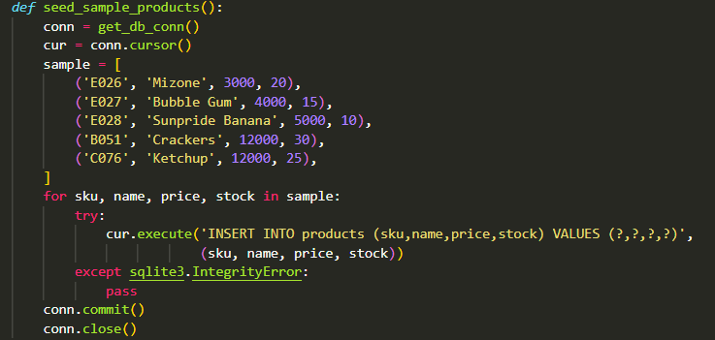
Sample Data Population:
This function populates the database with sample products for demonstration purposes:
- Sample Data Structure:
  - sample is a list of tuples
  - Each tuple contains: (sku, name, price, stock)
  - Five sample products: Mizone (drink), Bubble Gum, Sunpride Banana (juice), Crackers, and Ketchup
  - These are typical minimarket products in Indonesia
- Insertion Loop:
  - for sku, name, price, stock in sample: iterates through each product tuple
  - Python automatically unpacks each tuple into four separate variables
- SQL INSERT Statement:
  - INSERT INTO products (sku,name,price,stock) VALUES (?,?,?,?)
  - Specifies which columns to fill (id is auto-generated, so we skip it)
  - ? are placeholders for safe parameter binding (prevents SQL injection attacks)
  - The tuple (sku, name, price, stock) provides the actual values
- Error Handling:
  - try-except block catches errors (specifically sqlite3.IntegrityError)
  - This error occurs when trying to insert a product with a duplicate SKU
  - pass silently ignores the error, allowing the loop to continue
  - This ensures the function doesn't crash if products already exist in the database
- Data Persistence:
  - conn.commit() saves all successful insertions to the database file
  - conn.close() releases the database connection
Purpose: This function provides immediate usability for first-time users by pre-populating the database with sample products. Users can start exploring the application's features without needing to manually add products first.

Figure 3.6 - Product and CartItem Classes
Source: Personal documentation
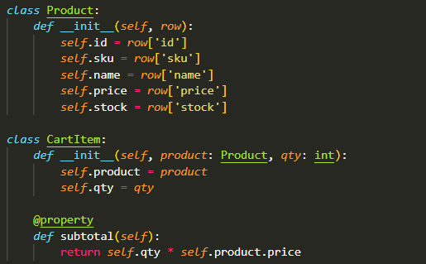
Data Model Classes:
These classes represent the core data structures of the application:
- Product Class:
  - Represents a single product from the database
  - __init__ is the constructor, called when creating a new Product object
  - row parameter is expected to be a database row (sqlite3.Row object)
  - Each attribute (id, sku, name, price, stock) is extracted from the database row
  - Why use a class? Makes code more readable: product.name instead of row['name']
- CartItem Class:
  - Represents a product in the shopping cart
  - Constructor takes two parameters:
    - product: A Product object
    - qty: Quantity (how many of this product)
  - Type hints (: Product, : int) document expected types (not enforced by Python)
- @property Decorator:
  - @property makes subtotal behave like an attribute, not a method
  - Instead of calling cart_item.subtotal(), you use cart_item.subtotal
  - The subtotal is calculated dynamically: qty × product.price
  - Example: If qty=2 and price=3000, subtotal=6000
- Usage Example:
- # Creating a Product from database row
- row = {'id': 1, 'sku': 'E026', 'name': 'Mizone', 'price': 3000, 'stock': 20}
- product = Product(row)
- # Creating a CartItem
- cart_item = CartItem(product, qty=2)
- print(cart_item.subtotal) # Output: 6000
Purpose: These classes provide a clean, object-oriented way to work with products and cart items, making the code more organized and easier to understand.

Figure 3.7 - Auto-Adjust Treeview Function
Source: Personal documentation
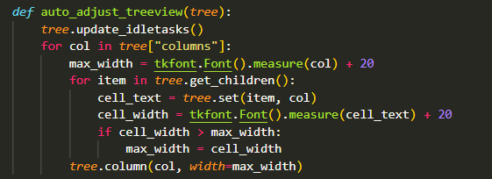
Auto-Adjust Column Width Function:
This function automatically adjusts column widths in a Treeview to fit content:
- Function Parameter:
  - tree: A ttk.Treeview widget (the table display)
- Update Idle Tasks:
  - tree.update_idletasks() ensures all pending GUI updates are completed
  - This makes sure all text is rendered before measuring
- Outer Loop - Iterate Columns:
  - tree["columns"] returns a tuple of column identifiers
  - Loops through each column (e.g., 'id', 'sku', 'name', 'price', 'stock')
- Initial Width Calculation:
  - tkfont.Font().measure(col) measures the pixel width of the column header text
  - + 20 adds 20 pixels of padding for better appearance
- Inner Loop - Check Cell Content:
  - tree.get_children() returns all row IDs in the Treeview
  - tree.set(item, col) gets the text content of a specific cell
  - tkfont.Font().measure(cell_text) measures the pixel width of that text
  - If this cell's width is larger than max_width, update max_width
- Apply Column Width:
  - tree.column(col, width=max_width) sets the column to the calculated width
  - This ensures no text is cut off and no space is wasted
Purpose: This function improves user experience by ensuring all text in the table is fully visible without making columns unnecessarily wide. It's called after populating the cart table to adjust for different product names.

Figure 3.8 - Main Application Class Structure
Source: Personal documentation
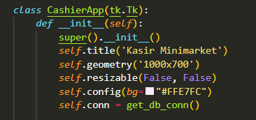
Main Application Class:
This class represents the entire application window:
- Class Declaration:
  - class CashierApp(tk.Tk): creates a class that inherits from Tkinter's Tk class
  - Inheritance means CashierApp "is a" Tk window with additional features
  - This is Object-Oriented Programming (OOP) - organizing code into classes
- Constructor Method:
  - def __init__(self): is the constructor, automatically called when creating an instance
  - super().__init__() calls the parent class (tk.Tk) constructor first
  - This initializes the basic window functionality
- Window Configuration:
  - self.title('Kasir Minimarket'): Sets the window title shown in the title bar
  - self.geometry('1000x700'): Sets window size to 1000 pixels wide by 700 pixels tall
  - self.resizable(False, False): Prevents window from being resized (both horizontal and vertical)
  - self.config(bg="#FFE7FC"): Sets background color using hexadecimal color code (light pink)
- Database Connection:
  - self.conn = get_db_conn(): Opens database connection once and stores it
  - self. makes it an instance variable, accessible in all methods of this class
  - Reusing one connection is more efficient than opening/closing repeatedly
Why Use a Class?
- Organization: All related data and functions are grouped together
- State Management: Instance variables (self.conn, self.cart) maintain application state
- Encapsulation: Methods can access shared data through self
- Inheritance: Inherits all Tk window functionality, adds custom features
Purpose: This class structure serves as the foundation of the application, initializing the main window and setting up essential components that will be built upon in subsequent methods.

Figure 3.9 - GUI Layout - Left Frame
Source: Personal documentation
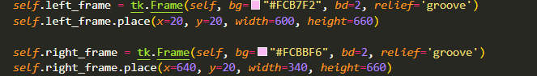
Frame Creation:
- Left Frame:
  - tk.Frame(self, ...): Creates a container widget inside the main window (self)
  - bg="#FCB7F2": Background color (pink shade)
  - bd=2: Border width of 2 pixels
  - relief='groove': Border style (creates a 3D grooved effect)
  - place(): Uses absolute positioning
    - x=20, y=20: Position 20 pixels from left and top
    - width=600, height=660: Frame dimensions
  - Stored as self.left_frame to reference later
- Right Frame:
  - Similar structure but positioned differently
  - x=640: Positioned to the right of the left frame (600 + 20 padding + 20 gap)
  - width=340: Narrower than left frame
  - Will contain the cart and checkout area
Purpose: These frames divide the window into two main sections - product list on the left, cart and checkout on the right. This creates a clear, organized layout.

Figure 3.10 - Search Functionality
Source: Personal documentation
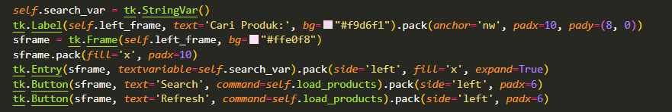Search Interface Components:
- String Variable:
  - self.search_var = tk.StringVar(): Creates a Tkinter variable for data binding
  - StringVar automatically syncs with Entry widgets
  - When user types, the variable updates; when variable changes, Entry updates
- Search Label:
  - tk.Label(...): Creates a text label
  - text='Cari Produk:': Indonesian for "Search Product:"
  - pack(anchor='nw'): Packs to north-west (top-left) corner
  - pady=(8, 0): Padding - 8 pixels on top, 0 on bottom
- Search Frame:
  - sframe: A nested frame to hold search controls horizontally
  - pack(fill='x'): Expands to fill available horizontal space
- Entry Widget:
  - tk.Entry(sframe, textvariable=self.search_var): Text input field
  - textvariable: Binds to search_var for two-way data sync
  - pack(side='left', fill='x', expand=True): Packs left, fills space, expands when window resizes
- Search Button:
  - command=self.load_products: Calls load_products method when clicked
  - pack(side='left'): Places button to the right of the Entry
  - padx=6: 6 pixels spacing on sides
- Refresh Button:
  - Also calls self.load_products
  - Purpose: Clear search and show all products
Purpose: Provides a user-friendly search interface where users can filter products by typing keywords. The search activates when clicking Search or Refresh buttons.

Figure 3.11 - Product Table (Treeview)
Source: Personal documentation
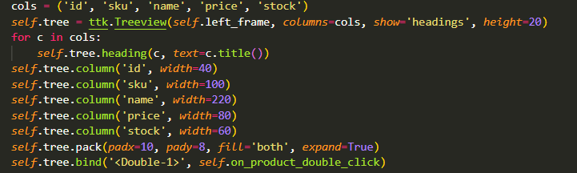Product Table Configuration:
- Column Definition:
  - cols = ('id', 'sku', 'name', 'price', 'stock'): Tuple of column identifiers
  - These match the database table columns
- Treeview Creation:
  - ttk.Treeview(): Creates a tree/table widget from themed widget set
  - columns=cols: Defines which columns to display
  - show='headings': Shows only column headers, not tree hierarchy icons
  - height=20: Number of visible rows (scrollable if more data)
- Setting Headers:
  - for c in cols: loops through each column
  - self.tree.heading(c, text=c.title()): Sets header text
  - .title() capitalizes first letter (e.g., 'id' becomes 'Id')
- Column Width Configuration:
  - self.tree.column('id', width=40): Sets ID column to 40 pixels
  - Different widths for different content types:
    - ID: narrow (40px)
    - SKU: medium (100px)
    - Name: wide (220px) for longer text
    - Price: medium (80px)
    - Stock: narrow (60px)
- Layout:
  - pack(padx=10, pady=8): Adds spacing around the table
  - fill='both', expand=True: Table expands to fill available space
- Event Binding:
  - bind('<Double-1>', self.on_product_double_click): Attaches event handler
  - '<Double-1>': Event code for double-click with left mouse button
  - When user double-clicks a row, on_product_double_click method is called
Purpose: The Treeview provides a clean, organized display of product data with interactive functionality. Double-clicking a product triggers the add-to-cart process.

Figure 3.12 - CRUD Buttons
Source: Personal documentation
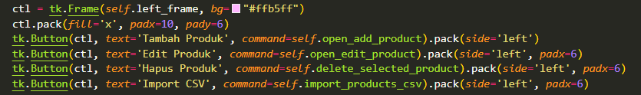
CRUD Control Buttons:
- Control Frame:
  - ctl = tk.Frame(...): Creates a frame to hold buttons
  - pack(fill='x'): Expands horizontally to fill width
- Add Product Button:
  - text='Tambah Produk': Indonesian for "Add Product"
  - command=self.open_add_product: Calls method to open add product dialog
  - pack(side='left'): Places buttons horizontally
- Edit Product Button:
  - text='Edit Produk': "Edit Product"
  - command=self.open_edit_product: Opens edit dialog for selected product
  - padx=6: 6 pixels spacing on sides
- Delete Product Button:
  - text='Hapus Produk': "Delete Product"
  - command=self.delete_selected_product: Deletes selected product after confirmation
- Import CSV Button:
  - command=self.import_products_csv: Opens file dialog to import products from CSV
CRUD Operations:
- Create: Tambah Produk (Add Product)
- Read: Displayed in the Treeview table
- Update: Edit Produk (Edit Product)
- Delete: Hapus Produk (Delete Product)
Purpose: Provides complete product management capabilities through a simple button interface.

Figure 3.13 - Cart Display (Right Frame)
Source: Personal documentation
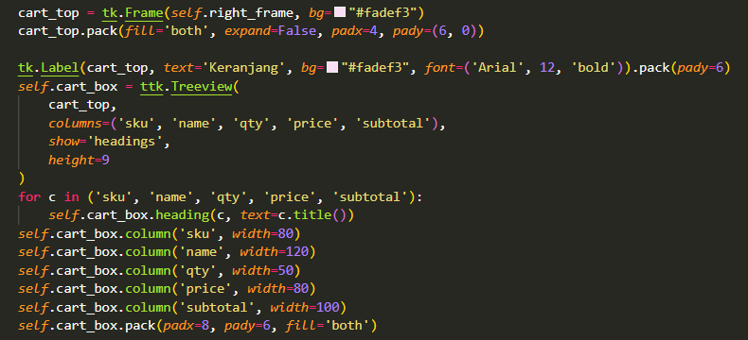
Cart Display Configuration:
- Cart Frame:
  - cart_top: Frame for cart section
  - expand=False: Doesn't expand when window resizes (fixed height)
  - Positioned at top of right_frame
- Cart Label:
  - text='Keranjang': Indonesian for "Cart"
  - font=('Arial', 12, 'bold'): Larger, bold font for heading
- Cart Table (cart_box):
  - self.cart_box: Treeview widget for displaying cart items
  - Columns: SKU, Name, Quantity, Price, Subtotal
  - height=9: Shows 9 rows at a time
- Column Configuration:
  - Similar to product table but different columns
  - Narrower columns since space is limited
  - Name column shorter (120px) to fit
Purpose: Displays items currently in the shopping cart with their quantities and prices, allowing users to review their selection before checkout.

Figure 3.14 - Cart Control Buttons
Source: Personal documentation
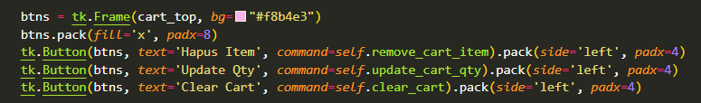
Cart Management Buttons:
- Buttons Frame:
  - Container for cart action buttons
  - Positioned below cart table
- Remove Item Button:
  - text='Hapus Item': "Delete Item"
  - command=self.remove_cart_item: Removes selected item from cart
- Update Quantity Button:
  - text='Update Qty': Update Quantity
  - command=self.update_cart_qty: Opens dialog to change quantity
- Clear Cart Button:
  - command=self.clear_cart: Empties entire cart after confirmation
Purpose: Provides cart management functionality, allowing users to modify cart contents before checkout.

Figure 3.15 - Total Display
Source: Personal documentation
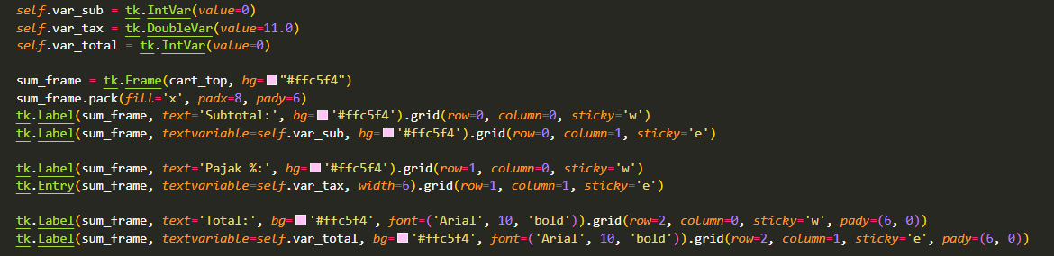
Total Calculation Display:
- Tkinter Variables:
  - self.var_sub = tk.IntVar(value=0): Subtotal (integer variable)
  - self.var_tax = tk.DoubleVar(value=11.0): Tax percentage (decimal variable, default 11%)
  - self.var_total = tk.IntVar(value=0): Total after tax
  - These special variables auto-update bound widgets
- Sum Frame:
  - sum_frame: Container for total display
  - Uses .grid() layout manager for table-like arrangement
- Subtotal Row:
  - Label with text "Subtotal:" in column 0
  - Label with textvariable=self.var_sub in column 1
  - sticky='w': Stick to west (left align)
  - sticky='e': Stick to east (right align)
- Tax Row:
  - Label "Pajak %:" (Indonesian for "Tax %")
  - Entry field bound to self.var_tax (user can change tax percentage)
  - width=6: Small input field
- Total Row:
  - Bolder font to emphasize final total
  - pady=(6, 0): Extra padding above for visual separation
Layout Manager - grid():
- Organizes widgets in rows and columns
- row=0, column=0: First cell
- sticky: Controls alignment within cell (n, s, e, w for north, south, east, west)
Purpose: Displays financial summary with subtotal, configurable tax, and final total. Values update automatically when cart changes.

Figure 3.16 - Checkout and Receipt Preview
Source: Personal documentation
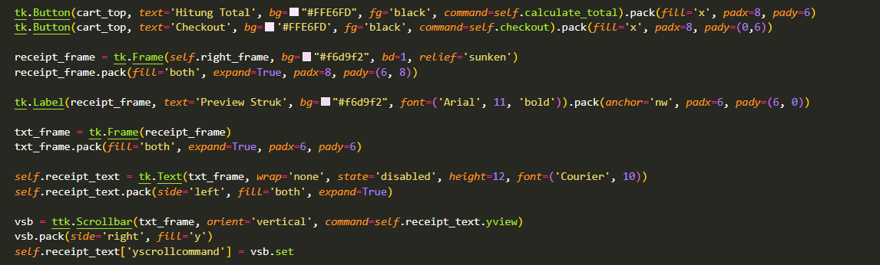Checkout and Receipt Components:
- Calculate Total Button:
  - text='Hitung Total': "Calculate Total"
  - command=self.calculate_total: Recalculates and shows total in popup
  - pack(fill='x'): Stretches to fill width
- Checkout Button:
  - command=self.checkout: Processes the transaction
  - Prominent placement for easy access
- Receipt Frame:
  - relief='sunken': 3D sunken border effect
  - expand=True: Takes remaining space in right_frame
- Receipt Label:
  - text='Preview Struk': "Receipt Preview"
  - Bold font to mark the section
- Text Widget:
  - self.receipt_text = tk.Text(...): Multi-line text display
  - wrap='none': Doesn't wrap long lines
  - state='disabled': Read-only (user can't edit)
  - height=12: 12 lines tall
  - font=('Courier', 10): Monospace font for aligned receipt
- Scrollbar:
  - ttk.Scrollbar(...): Vertical scrollbar
  - command=self.receipt_text.yview: Controls text widget scrolling
  - self.receipt_text['yscrollcommand'] = vsb.set: Links text widget to scrollbar
  - Bidirectional binding for synchronized scrolling
- Initialization:
- self.cart = []
- self.load_products()
  - self.cart = []: Empty list to store CartItem objects
  - self.load_products(): Loads initial product data
Purpose: Provides checkout functionality and receipt preview area. The monospace font ensures proper alignment of receipt text.

Figure 3.17 - Load Products Method
Source: Personal documentation
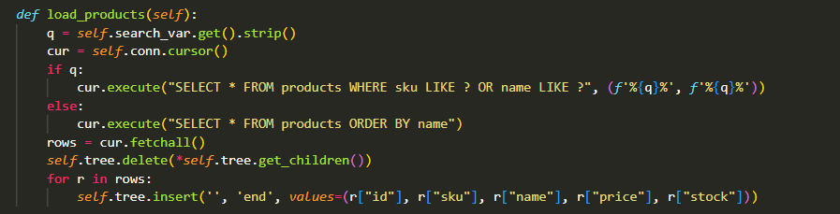Loading Products from Database:
- Get Search Query:
  - q = self.search_var.get().strip(): Gets search text
  - .strip(): Removes leading/trailing whitespace
- Database Cursor:
  - cur = self.conn.cursor(): Creates cursor for query execution
- Conditional Query:
  - If search query exists (if q:):
    - SELECT * FROM products WHERE sku LIKE ? OR name LIKE ?
    - LIKE operator: Pattern matching
    - f'%{q}%': Wraps query in % wildcards (matches anywhere in text)
    - Example: Query "miz" matches "Mizone"
    - OR: Searches both SKU and name columns
  - If no search query (else:):
    - SELECT * FROM products ORDER BY name
    - Gets all products, sorted alphabetically by name
- Fetch Results:
  - rows = cur.fetchall(): Gets all matching rows as a list
- Clear Table:
  - self.tree.delete(*self.tree.get_children()): Removes all current rows
  - get_children(): Returns tuple of row IDs
  - *: Unpacks tuple as separate arguments to delete()
- Populate Table:
  - for r in rows: loops through each database row
  - self.tree.insert('', 'end', values=(...)): Adds row to table
    - First parameter '': Parent (empty = root level)
    - 'end': Insert at bottom of list
    - values: Tuple of data to display
SQL LIKE Operator Examples:
- '%miz%' matches: "Mizone", "Amazing", "miz"
- 'miz%' matches: "Mizone", "mizuno" (starts with "miz")
- '%miz' matches: "miz", "Gomiz" (ends with "miz")
Purpose: Provides search and display functionality. Called on app start, when searching, after adding/editing/deleting products.

Figure 3.18 - Add to Cart (Double Click)
Source: Personal documentation
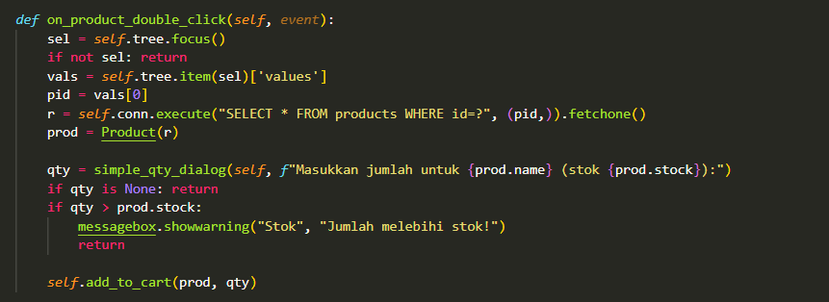Double-Click Event Handler:
- Get Selected Item:
  - sel = self.tree.focus(): Gets ID of focused (selected) row
  - if not sel: return: Guards against no selection
- Extract Product ID:
  - vals = self.tree.item(sel)['values']: Gets row data as tuple
  - .item(sel): Returns dictionary with item data
  - ['values']: Extracts the values tuple
  - pid = vals[0]: First value is product ID
- Query Full Product Data:
  - self.conn.execute(...): Executes SQL query directly
  - .fetchone(): Returns single row
  - Why query again? Treeview shows formatted data (e.g., "Rp3,000"), we need raw numbers
- Create Product Object:
  - prod = Product(r): Converts database row to Product object
- Show Quantity Dialog:
  - simple_qty_dialog(self, ...): Shows dialog (function defined later)
  - Prompt includes product name and current stock
  - Returns entered quantity or None if canceled
- Validate Quantity:
  - if qty is None: return: User canceled
  - if qty > prod.stock:: Check if requested quantity exceeds stock
  - messagebox.showwarning(...): Shows warning popup
  - return: Exits function, doesn't add to cart
- Add to Cart:
  - self.add_to_cart(prod, qty): Calls method to add item
Purpose: Handles the user interaction of double-clicking a product to add it to the cart, with proper validation.

Figure 3.19 - Add to Cart Logic
Source: Personal documentation
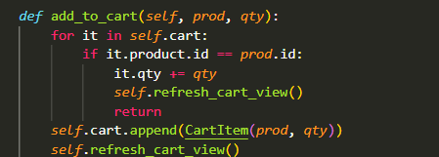
Cart Update Logic:
- Check for Existing Item:
  - for it in self.cart: loops through cart items
  - if it.product.id == prod.id: checks if product already in cart
  - Compares by ID (not name, in case of duplicates)
- Update Existing Item:
  - it.qty += qty: Adds new quantity to existing quantity
  - Example: Had 2, adding 3 more = 5 total
  - self.refresh_cart_view(): Updates display
  - return: Exits function early
- Add New Item:
  - Only executes if loop doesn't find existing item
  - self.cart.append(CartItem(prod, qty)): Adds new CartItem to list
  - self.refresh_cart_view(): Updates display
Cart Data Structure:
self.cart = [
CartItem(product=Product(...), qty=2),
CartItem(product=Product(...), qty=1),
]
Purpose: Manages cart state intelligently - increments quantity for duplicate items instead of creating separate entries.

Figure 3.20 - Refresh Cart Display
Source: Personal documentation
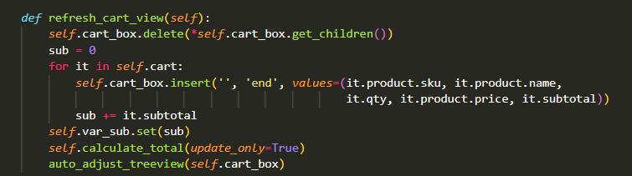Cart Display Update:
- Clear Cart Table:
  - Same pattern as clearing product table
  - Removes all rows before repopulating
- Initialize Subtotal:
  - sub = 0: Accumulator variable starts at zero
- Populate Cart Table:
  - for it in self.cart: loops through CartItem objects
  - self.cart_box.insert(...): Adds row to cart table
  - Displays: SKU, name, quantity, unit price, subtotal
  - it.subtotal: Uses the @property we defined earlier
  - sub += it.subtotal: Running total
- Update Subtotal Variable:
  - self.var_sub.set(sub): Updates the IntVar
  - Automatically refreshes any labels bound to this variable
- Recalculate Total:
  - self.calculate_total(update_only=True): Updates total with tax
  - update_only=True: Doesn't show popup, just updates display
- Adjust Column Widths:
  - auto_adjust_treeview(self.cart_box): Makes columns fit content
  - Prevents text from being cut off
Why Separate Method? Called from multiple places:
- After adding item
- After removing item
- After updating quantity
- After clearing cart
- After checkout (to show empty cart)
Purpose: Keeps cart display synchronized with cart data and recalculates totals automatically.

Figure 3.21 - Cart Management Methods
Source: Personal documentation
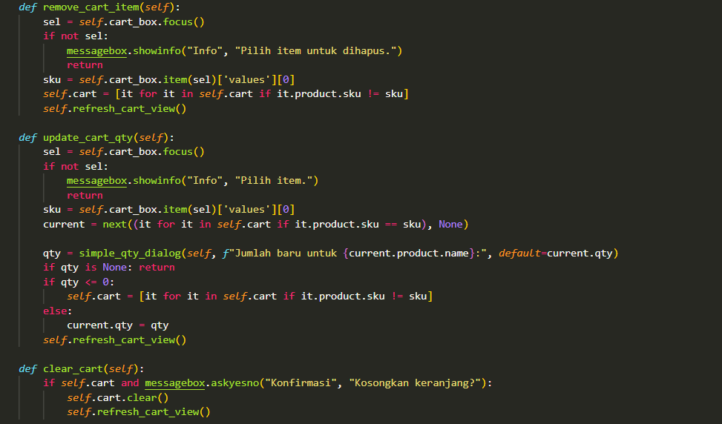
Cart Management Functions:
- Remove Cart Item:
  - Gets selected item from cart_box
  - Validates selection
  - Extracts SKU from first column
  - List comprehension: [it for it in self.cart if it.product.sku != sku]
    - Creates new list excluding the item with matching SKU
    - Filters out the item to remove
  - Refreshes display
- Update Cart Quantity:
  - Gets selected item
  - Finds CartItem object using next()
    - next(...): Returns first match from generator
    - Generator: (it for it in self.cart if it.product.sku == sku)
    - Returns None if no match found
  - Shows dialog with current quantity as default
  - If qty <= 0: Remove item (list comprehension)
  - Else: Update quantity directly: current.qty = qty
  - Refreshes display
- Clear Cart:
  - if self.cart and ...: Only asks if cart has items
  - messagebox.askyesno(...): Confirmation dialog
  - Returns True if Yes, False if No
  - self.cart.clear(): Empties the list
  - Refreshes display
List Comprehension Syntax:
new_list = [expression for item in list if condition]
# Example: Remove items with sku 'E026'
cart = [it for it in self.cart if it.product.sku != 'E026']
Purpose: Provides full cart management - remove, update, and clear functionality with appropriate validation.

Figure 3.22 - CRUD Product Methods
Source: Personal documentation
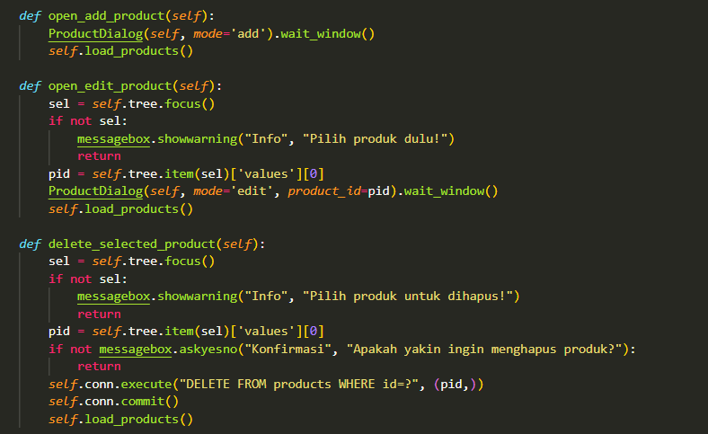
CRUD Operations:
- Open Add Product:
  - ProductDialog(self, mode='add'): Creates dialog window in add mode
  - .wait_window(): Blocks until dialog is closed
  - self.load_products(): Refreshes product list after dialog closes
- Open Edit Product:
  - Validates selection first
  - Extracts product ID: pid = self.tree.item(sel)['values'][0]
  - ProductDialog(self, mode='edit', product_id=pid): Opens dialog in edit mode
  - Passes product_id so dialog can load existing data
  - Refreshes product list after editing
- Delete Selected Product:
  - Validates selection
  - messagebox.askyesno(...): Confirmation dialog
  - Indonesian text: "Apakah yakin ingin menghapus produk?" = "Are you sure you want to delete product?"
  - if not ...: If user clicks No, exit function
  - DELETE FROM products WHERE id=?: SQL delete statement
  - self.conn.commit(): Saves changes to database
  - self.load_products(): Refreshes list to remove deleted item
wait_window() Explanation:
- Pauses execution until the dialog window is closed
- Ensures dialog is handled before refreshing the product list
- Without it, product list might refresh before user finishes adding/editing
Purpose: Implements Create, Update, and Delete operations for product management with proper validation and user feedback.

Figure 3.23 - CSV Import
Source: Personal documentation
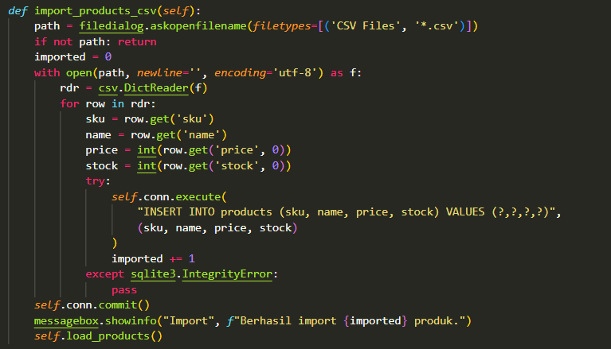
CSV Import Function:
- File Selection:
  - filedialog.askopenfilename(...): Opens file browser dialog
  - filetypes=[('CSV Files', '*.csv')]: Filters to show only CSV files
  - Returns full path to selected file
  - Returns empty string if user cancels
  - if not path: return: Exit if canceled
- Counter Initialization:
  - imported = 0: Tracks successful imports
- Open CSV File:
  - with open(path, newline='', encoding='utf-8') as f:
  - with: Context manager (auto-closes file)
  - newline='': Required parameter for CSV reading
  - encoding='utf-8': Handles special characters

- CSV Reading:
  - rdr = csv.DictReader(f): Reads CSV as dictionaries
  - First row becomes column names (keys)
  - Each subsequent row becomes a dictionary
- Expected CSV Format:
- sku,name,price,stock
- E026,Mizone,3000,20
- E027,Bubble Gum,4000,15
- Extract Values:
  - row.get('sku'): Gets value from 'sku' column
  - .get() returns None if column doesn't exist
  - int(row.get('price', 0)): Converts to integer, defaults to 0 if missing
- Insert to Database:
  - try-except: Catches duplicate SKU errors
  - sqlite3.IntegrityError: Error when SKU already exists (UNIQUE constraint)
  - pass: Silently skips duplicates
  - imported += 1: Only increments on successful insert
- Batch Commit:
  - self.conn.commit(): Saves all changes at once
  - More efficient than committing after each insert
- User Feedback:
  - Shows count of imported products
  - Indonesian: "Berhasil import" = "Successfully imported"
  - Refreshes product list
Purpose: Enables bulk product import from CSV files, useful for initial setup or adding many products at once.

Figure 3.24 - Calculate Total
Source: Personal documentation
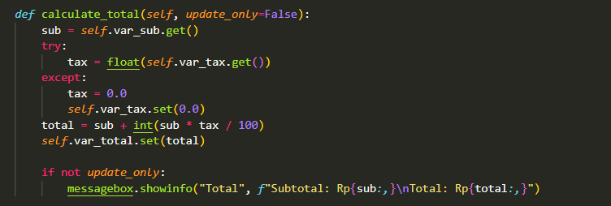Total Calculation:
- Get Subtotal:
  - sub = self.var_sub.get(): Retrieves current subtotal value
- Get Tax Percentage:
  - try-except: Handles invalid input
  - float(self.var_tax.get()): Converts to decimal number
  - If conversion fails (user entered text): sets tax to 0.0
- Calculate Total:
  - Formula: total = sub + int(sub * tax / 100)
  - Example: subtotal=10000, tax=11%
    - Tax amount: 10000 × 11 / 100 = 1100
    - Total: 10000 + 1100 = 11100
  - int(): Converts to whole number (no cents)
- Update Variable:
  - self.var_total.set(total): Updates total display
- Conditional Popup:
  - if not update_only:: Only shows popup when button is clicked
  - update_only=True: Silent update (called from refresh_cart_view)
  - \n: Newline character for multi-line message
  - Rp{sub:,}: Formats with thousands separator
Why update_only Parameter?
- Called from two places:
  - Button click: Shows popup (update_only=False)
  - Cart refresh: Silent update (update_only=True)
- Avoids annoying popups every time cart changes
Purpose: Calculates final total with tax, updates display, optionally shows confirmation popup.

Figure 3.25 - Generate Receipt Text
Source: Personal documentation
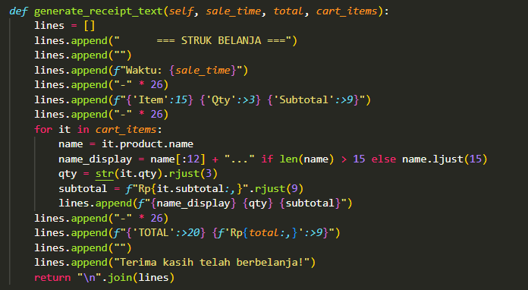
Receipt Text Formatting:
- Parameters:
  - sale_time: Transaction timestamp string
  - total: Final amount after tax
  - cart_items: List of CartItem objects
- Lines List:
  - Builds receipt as list of strings
  - Each element becomes one line
- Header:
  - "=== STRUK BELANJA ===" (Shopping Receipt)
  - Centered with spaces
  - Empty line for spacing
- Timestamp:
  - f"Waktu: {sale_time}": Indonesian for "Time:"
  - Shows transaction date and time
- Column Headers:
  - f"{'Item':15}": Left-aligned in 15-character field
  - f"{'Qty':>3}": Right-aligned in 3-character field (:> means right-align)
  - f"{'Subtotal':>9}": Right-aligned in 9-character field
  - Separator line: - repeated 26 times
- Item Lines:
  - Truncate long names:
    - name[:12] + "..." if name longer than 15 chars
    - name.ljust(15) if shorter (left-justified, padded with spaces)
  - str(it.qty).rjust(3): Right-align quantity in 3 chars
  - f"Rp{it.subtotal:,}".rjust(9): Format price, right-align in 9 chars
- Total Line:
  - {'TOTAL':>20}: Right-align in 20 chars
  - Nested f-string for formatted price
- Footer:
  - Thank you message in Indonesian
- Join Lines:
  - "\n".join(lines): Combines list into single string with newlines
Example Output:
=== STRUK BELANJA ===

Waktu: 2025-01-15 14:30:45
--------------------------
Item Qty Subtotal
--------------------------
Mizone 2 Rp6,000
Bubble Gum 1 Rp4,000
--------------------------
TOTAL Rp10,000

Terima kasih telah berbelanja!
Purpose: Creates a clean, well-formatted text receipt with proper alignment for printing or display.

Figure 3.26 - Render Receipt to GUI
Source: Personal documentation
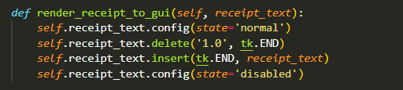
Display Receipt in Text Widget:
- Enable Editing:
  - config(state='normal'): Changes text widget to editable mode
  - Required before modifying content
- Clear Previous Content:
  - delete('1.0', tk.END): Removes all text
  - '1.0': Line 1, character 0 (start)
  - tk.END: End of all text
- Insert Receipt:
  - insert(tk.END, receipt_text): Adds receipt at end
  - Since we just cleared, this is at the beginning
- Disable Editing:
  - config(state='disabled'): Makes text read-only
  - Prevents user from accidentally modifying receipt
  - User can still select and copy text
Why Toggle State?
- Text widget must be 'normal' to modify content
- Set back to 'disabled' to protect receipt text
- Standard pattern for read-only displays
Purpose: Displays the receipt in the preview area with protection against accidental edits.

Figure 3.27 - Checkout Process (Part 1)
Source: Personal documentation
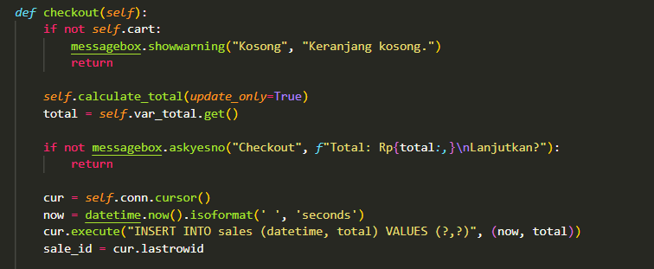Checkout Process - Transaction Creation:

- Validate Cart:
  - if not self.cart:: Checks if cart is empty
  - Empty lists are "falsy" in Python
  - Shows warning in Indonesian: "Keranjang kosong" = "Cart empty"
- Calculate Final Total:
  - self.calculate_total(update_only=True): Updates total silently
  - total = self.var_total.get(): Gets calculated total
- Confirmation Dialog:
  - messagebox.askyesno(...): Yes/No dialog
  - Shows total amount
  - Indonesian: "Lanjutkan?" = "Continue?"
  - Returns True if Yes, False if No
  - if not ...: If user clicks No, exit function
- Create Cursor:
  - cur = self.conn.cursor(): For executing SQL
- Generate Timestamp:
  - datetime.now(): Current date and time
  - .isoformat(' ', 'seconds'): Formats as string
    - First parameter: separator between date and time
    - 'seconds': Precision (excludes milliseconds)
  - Example output: "2025-01-15 14:30:45"
- Insert Transaction Header:
  - INSERT INTO sales (datetime, total) VALUES (?,?)
  - Stores when transaction occurred and total amount
  - (now, total): Provides the values
- Get Transaction ID:
  - sale_id = cur.lastrowid: Gets auto-generated ID
  - Needed to link transaction details (next step)
Purpose: Begins checkout process with validation, user confirmation, and transaction header creation.

Figure 3.28 - Checkout Process (Part 2)
Source: Personal documentation
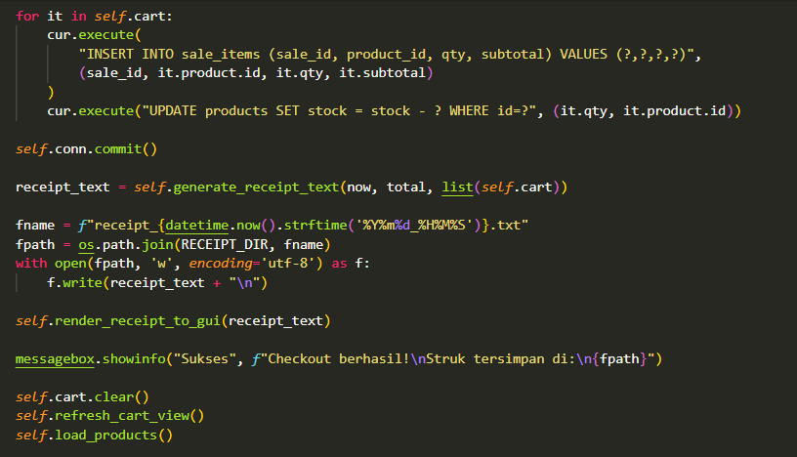Checkout Process - Details, Stock, Receipt:
- Save Transaction Details:
  - for it in self.cart: loops each CartItem
  - INSERT INTO sale_items ...: Saves what was sold
    - sale_id: Links to transaction header
    - it.product.id: Which product
    - it.qty: How many
    - it.subtotal: Price × quantity
- Update Stock:
  - UPDATE products SET stock = stock - ? WHERE id=?
  - SQL arithmetic: stock = stock - qty
  - Example: stock was 50, sold 3, becomes 47
  - Uses product ID to update correct row
- Commit All Changes:
  - self.conn.commit(): Saves everything
  - Critical: Without this, nothing is saved
  - Ensures atomicity (all-or-nothing)
- Generate Receipt:
  - self.generate_receipt_text(...): Creates formatted receipt
  - list(self.cart): Passes cart copy (since we'll clear it)
- Create Filename:
  - strftime('%Y%m%d_%H%M%S'): Formats datetime
    - %Y: 4-digit year
    - %m: 2-digit month
    - %d: 2-digit day
    - %H: Hour (24-hour format)
    - %M: Minute
    - %S: Second
  - Example: "receipt_20250115_143045.txt"
  - Unique filename prevents overwriting
- Save Receipt File:
  - os.path.join(RECEIPT_DIR, fname): Full path
  - with open(..., 'w', encoding='utf-8') as f:: Opens file for writing
  - f.write(receipt_text + "\n"): Writes receipt with final newline
- Display Receipt:
  - self.render_receipt_to_gui(receipt_text): Shows in preview area
- Success Message:
  - Indonesian: "Checkout berhasil!" = "Checkout successful!"
  - "Struk tersimpan di:" = "Receipt saved at:"
  - Shows file path
- Cleanup:
  - self.cart.clear(): Empties cart list
  - self.refresh_cart_view(): Updates display (now empty)
  - self.load_products(): Reloads products to show updated stock
Purpose: Completes checkout by saving transaction details, updating stock, generating receipt, and resetting for next transaction.

Figure 3.29 - Quantity Dialog Function
Source: Personal documentation
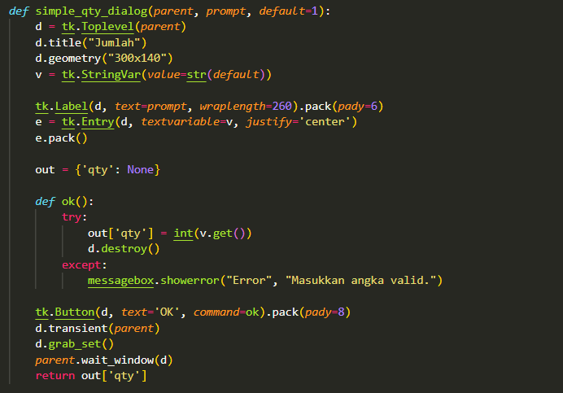Quantity Input Dialog:
- Function Parameters:
  - parent: Parent window (makes dialog appear on top)
  - prompt: Message to display
  - default=1: Default value (keyword argument)
- Create Dialog Window:
  - d = tk.Toplevel(parent): Creates popup window
  - Toplevel: Secondary window (not main Tk window)
  - Title: "Jumlah" (Indonesian for "Quantity")
- StringVar:
  - v = tk.StringVar(value=str(default)): Creates bound variable
  - Converts default number to string
  - Syncs with Entry widget
- Prompt Label:
  - wraplength=260: Text wraps at 260 pixels
  - Handles long product names
- Entry Widget:
  - textvariable=v: Two-way binding
  - justify='center': Centers text input
- Output Dictionary:
  - out = {'qty': None}: Stores result
  - Using dict allows modification in nested function (closure)
- OK Function:
  - Nested function (has access to outer scope)
  - try-except: Validates numeric input
  - int(v.get()): Converts string to integer
  - d.destroy(): Closes dialog
  - If conversion fails: shows error (Indonesian: "Masukkan angka valid" = "Enter valid number")
- Dialog Configuration:
  - d.transient(parent): Dialog stays on top of parent
  - d.grab_set(): Modal dialog (blocks interaction with other windows)
  - parent.wait_window(d): Pauses execution until dialog closes
- Return Value:
  - Returns entered quantity or None if error/canceled
Purpose: Reusable dialog for quantity input with validation, used when adding or updating cart items.

Figure 3.30 - Product Dialog Class (Part 1)
Source: Personal documentation
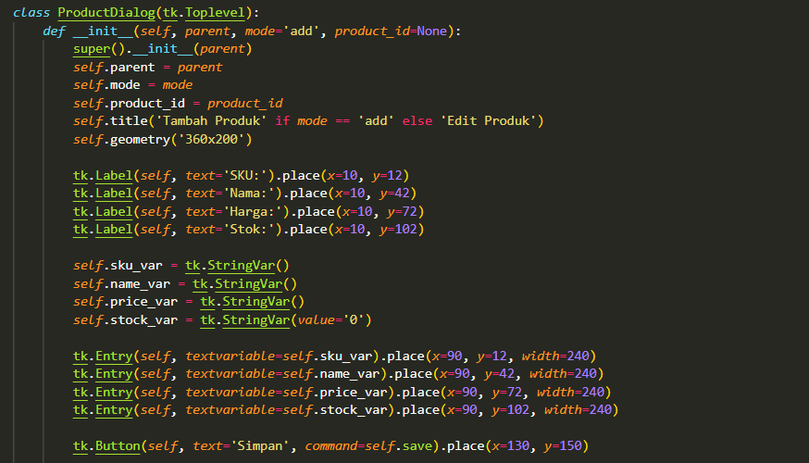Product Form Dialog - Structure:
- Class Declaration:
  - Inherits from tk.Toplevel (dialog window)
  - Used for both add and edit operations
- Constructor Parameters:
  - parent: Main application window
  - mode='add': Default mode (add new product)
  - product_id=None: Only used in edit mode
- Store Parameters:
  - self.parent, self.mode, self.product_id: Accessible in all methods
- Dynamic Title:
  - Ternary operator: 'Tambah Produk' if mode == 'add' else 'Edit Produk'
  - Indonesian: "Add Product" or "Edit Product"
- Form Labels:
  - Four labels aligned vertically at x=10
  - y-coordinates: 12, 42, 72, 102 (30-pixel spacing)
  - Indonesian: Nama=Name, Harga=Price, Stok=Stock
- StringVars:
  - One for each input field
  - stock_var defaults to '0'
  - Stored as instance variables (self.)
- Entry Widgets:
  - All aligned at x=90 (to the right of labels)
  - width=240 pixels
  - Bound to corresponding StringVars
- Save Button:
  - Indonesian: "Simpan" = "Save"
  - command=self.save: Calls save method
  - Centered horizontally (x=130)
Purpose: Creates a form dialog for adding or editing products with a clean, aligned layout.

Figure 3.31 - Product Dialog Class (Part 2)
Source: Personal documentation
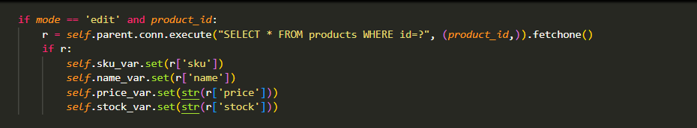Loading Data for Edit Mode:
- Conditional Loading:
  - if mode == 'edit' and product_id:: Only in edit mode with valid ID
- Query Product:
  - self.parent.conn.execute(...): Uses parent's database connection
  - .fetchone(): Returns single row or None
- Populate Fields:
  - .set() method: Updates StringVar values
  - str(r['price']): Converts number to string
  - str(r['stock']): Same for stock
  - These values appear in the Entry widgets
Purpose: In edit mode, loads existing product data into the form fields for modification.

Figure 3.32 - Product Dialog Save Method
Source: Personal documentation
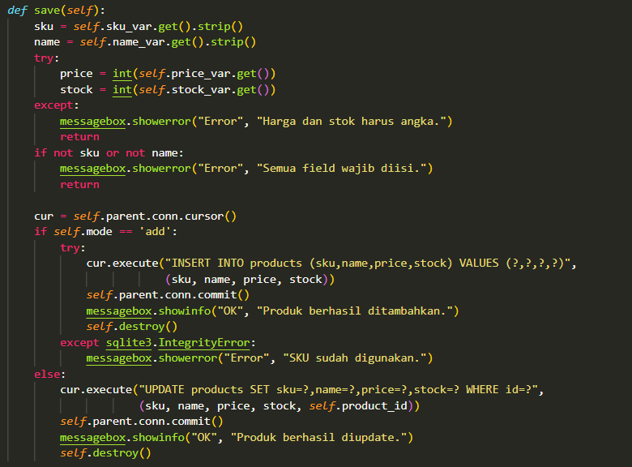
Save Method - Validation and Database Operations:

- Get Input Values:
  - .get().strip(): Gets text and removes whitespace
  - Prevents spaces causing issues
- Validate Numbers:
  - try-except: Catches conversion errors
  - int(): Converts string to integer
  - If fails: shows error (Indonesian: "Harga dan stok harus angka" = "Price and stock must be numbers")
- Validate Required Fields:
  - if not sku or not name:: Checks for empty fields
  - Empty strings are "falsy"
  - Indonesian: "Semua field wajib diisi" = "All fields must be filled"
- Add Mode Branch:
  - if self.mode == 'add':
  - INSERT INTO products ...: Adds new product
  - try-except: Catches duplicate SKU error
  - sqlite3.IntegrityError: Violates UNIQUE constraint
  - Success: "Produk berhasil ditambahkan" = "Product successfully added"
  - self.destroy(): Closes dialog
- Edit Mode Branch:
  - else: (mode is 'edit')
  - UPDATE products SET ... WHERE id=?: Modifies existing product
  - Uses self.product_id to update correct row
  - Success: "Produk berhasil diupdate" = "Product successfully updated"
  - Also closes dialog
Purpose: Validates input and saves product to database, handling both add and edit operations with appropriate error checking.

Figure 3.33 - Opening Window Function
Source: Personal documentation
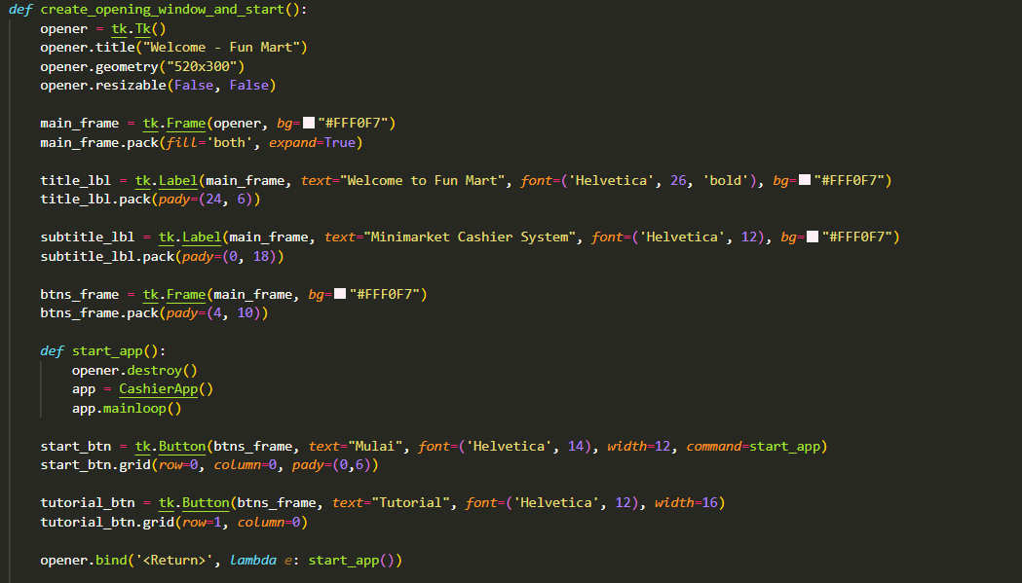Welcome Screen - Part 1:
- Create Window:
  - opener = tk.Tk(): Main window for welcome screen
  - resizable(False, False): Fixed size
- Main Frame:
  - Container for all welcome screen elements
  - Light pink background
- Title Label:
  - "Welcome to Fun Mart"
  - Large bold font (26 point)
  - pady=(24, 6): 24px above, 6px below
- Subtitle Label:
  - "Minimarket Cashier System"
  - Smaller font (12 point)
- Buttons Frame:
  - Container for buttons
- Start Function:
  - Nested function (closure)
  - opener.destroy(): Closes welcome window
  - app = CashierApp(): Creates main application
  - app.mainloop(): Starts main application event loop
- Start Button:
  - Indonesian: "Mulai" = "Start"
  - Calls start_app() when clicked
  - grid(row=0, column=0): First row
- Tutorial Button:
  - Second row (row=1)
  - Command will be set later
- Keyboard Shortcut:
  - opener.bind('<Return>', ...): Binds Enter key
  - lambda e:: Anonymous function ignoring event parameter
  - Pressing Enter starts the app
Purpose: Creates an attractive welcome screen before the main application opens.

Figure 3.34 - Tutorial Frame
Source: Personal documentation
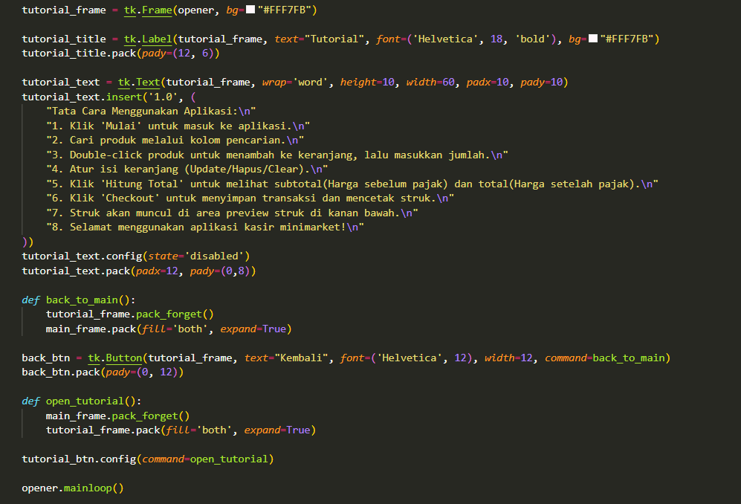
Tutorial Screen:
- Tutorial Frame:
  - Hidden initially (not packed)
  - Contains tutorial content
- Tutorial Title:
  - Bold heading
- Tutorial Text Widget:
  - wrap='word': Wraps at word boundaries
  - Multi-line text widget
  - Lists 8 steps in Indonesian
  - config(state='disabled'): Makes read-only after inserting text
- Back Function:
  - tutorial_frame.pack_forget(): Hides tutorial frame
  - main_frame.pack(...): Shows main frame again
- Back Button:
  - Indonesian: "Kembali" = "Back"
  - Returns to main welcome screen
- Open Tutorial Function:
  - Opposite of back: hides main, shows tutorial
- Configure Tutorial Button:
  - tutorial_btn.config(command=open_tutorial): Sets command after creation
- Start Event Loop:
  - opener.mainloop(): Keeps welcome window open
Purpose: Provides tutorial instructions accessible from welcome screen, using frame swapping to show/hide content.

Figure 3.35 - Application Entry Point
Source: Personal documentation
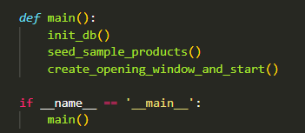
Program Entry Point:
- Main Function:
  - init_db(): Creates database tables if needed
  - seed_sample_products(): Adds sample data
  - create_opening_window_and_start(): Shows welcome screen
- Name Guard:
  - if __name__ == '__main__':: Only runs if file executed directly
  - Not executed if file is imported as a module
  - Python best practice
Startup Sequence:
- Database initialization
- Sample data (if first run)
- Welcome screen appears
- User clicks "Mulai"
- Main application opens
- User interacts with cashier system
Purpose: Defines the application entry point with proper initialization sequence.

3.2 APPLICATION SCREENSHOTS
Detailed screenshots demonstrating the key features and user interface of the Minimarket Cashier System:
Figure 3.36 - Welcome Screen
Source: Personal documentation
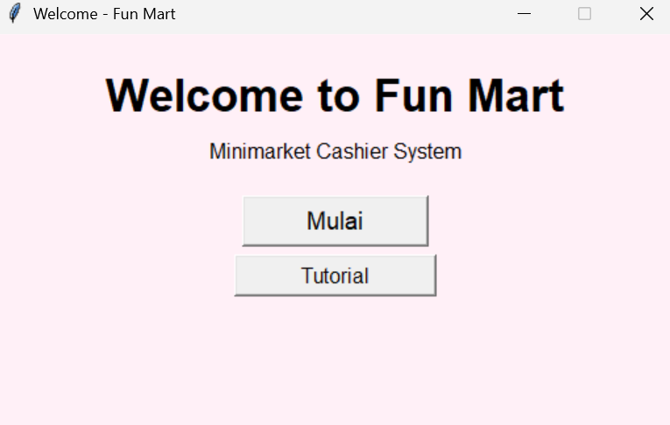
The welcome screen serves as the entry point to the application. It features the application title "Welcome to Fun Mart" and "Minimarket Cashier System" subtitle. Two buttons are provided: "Mulai" (Start) to enter the application, and "Tutorial" to view usage instructions.

Figure 3.37 - Main Application Interface
Source: Personal documentation
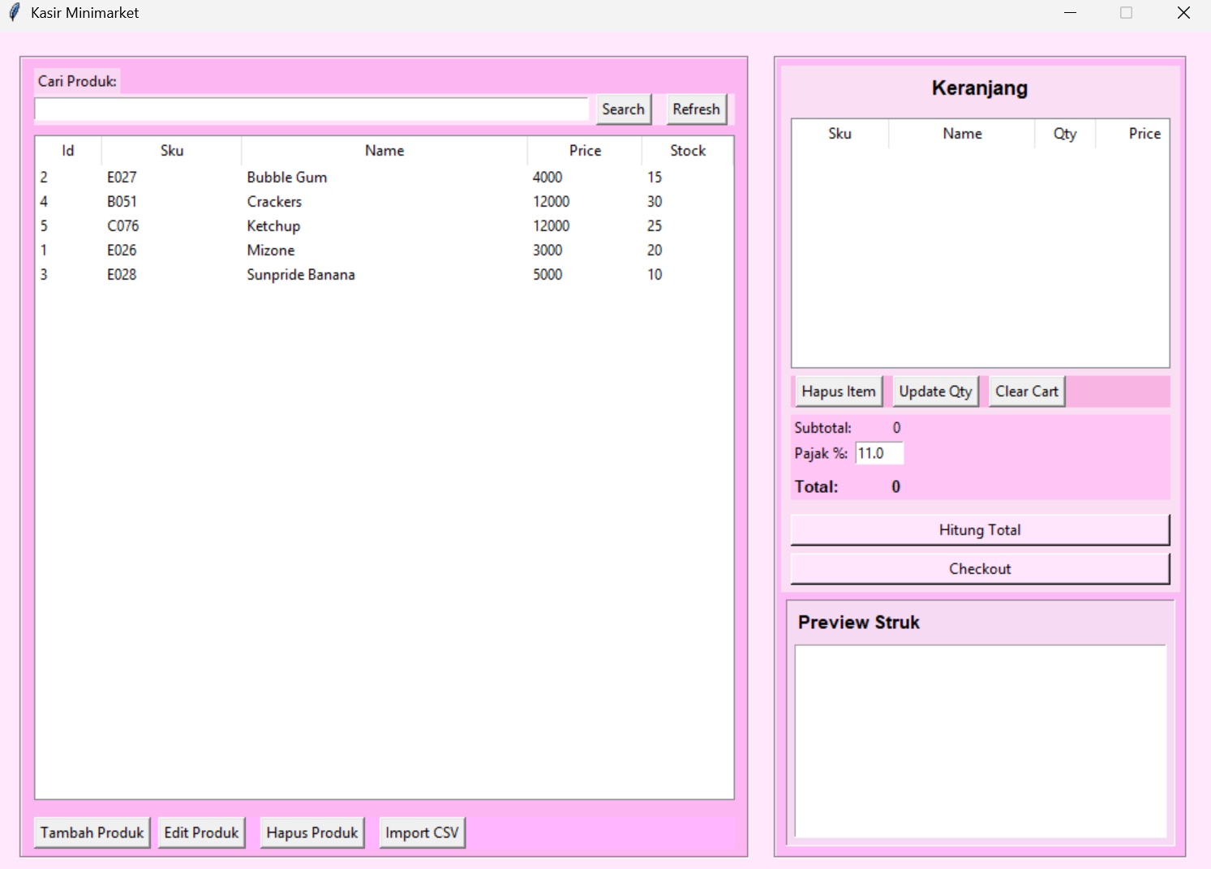
The main interface is divided into two main sections:
- Left Panel (600px): Displays the product table with columns for ID, SKU, Name, Price, and Stock. Includes search functionality and CRUD buttons at the bottom.
- Right Panel (340px): Shows the shopping cart table, total calculation area, checkout button, and receipt preview.

Figure 3.38 - Tutorial Screen
Source: Personal documentation
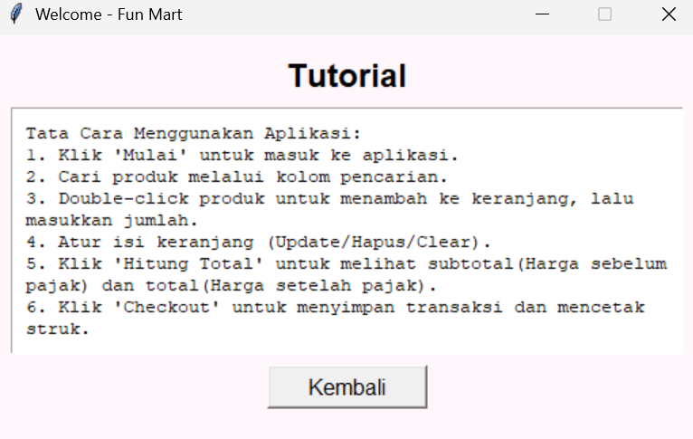
The tutorial screen provides step-by-step instructions in Indonesian on how to use the application. Users can return to the welcome screen using the "Kembali" (Back) button.

Figure 3.39 - Product Search
Source: Personal documentation
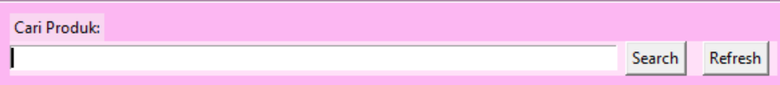
Demonstrates the search functionality filtering products based on keywords entered in the search field.

Figure 3.40 - Add Product Dialog
Source: Personal documentation
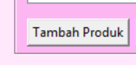
The product dialog in "add" mode, showing empty fields for SKU, Name, Price, and Stock.

Figure 3.41 - Edit Product Dialog
Source: Personal documentation
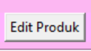
The same dialog in "edit" mode, with fields pre-populated with existing product data.

Figure 3.42 - Quantity Input Dialog
Source: Personal documentation
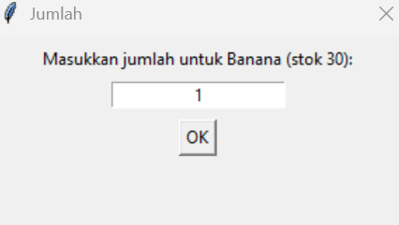
The quantity input dialog that appears when double-clicking a product, showing the product name and available stock.

Figure 3.43 - Shopping Cart with Items
Source: Personal documentation
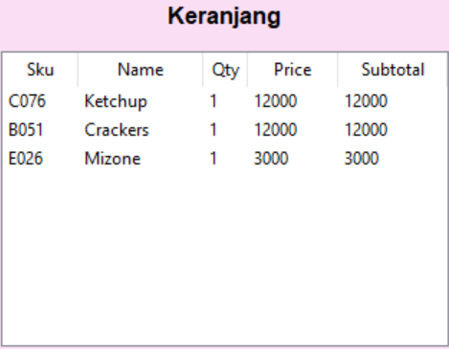
Cart table populated with multiple items, showing SKU, name, quantity, unit price, and subtotal for each item.

Figure 3.44 - Checkout Confirmation
Source: Personal documentation
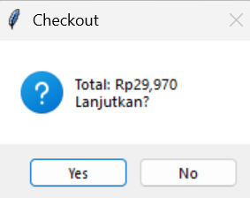
The confirmation dialog displaying the total amount before finalizing the checkout.

Figure 3.45 - Receipt Preview
Source: Personal documentation
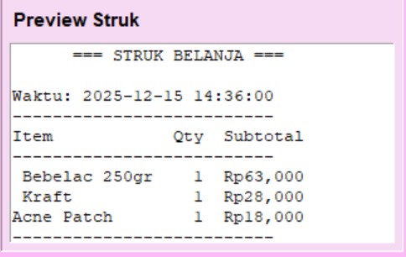
The receipt preview area displaying the formatted receipt after successful checkout.

Figure 3.46 - CSV Import Dialog
Source: Personal documentation
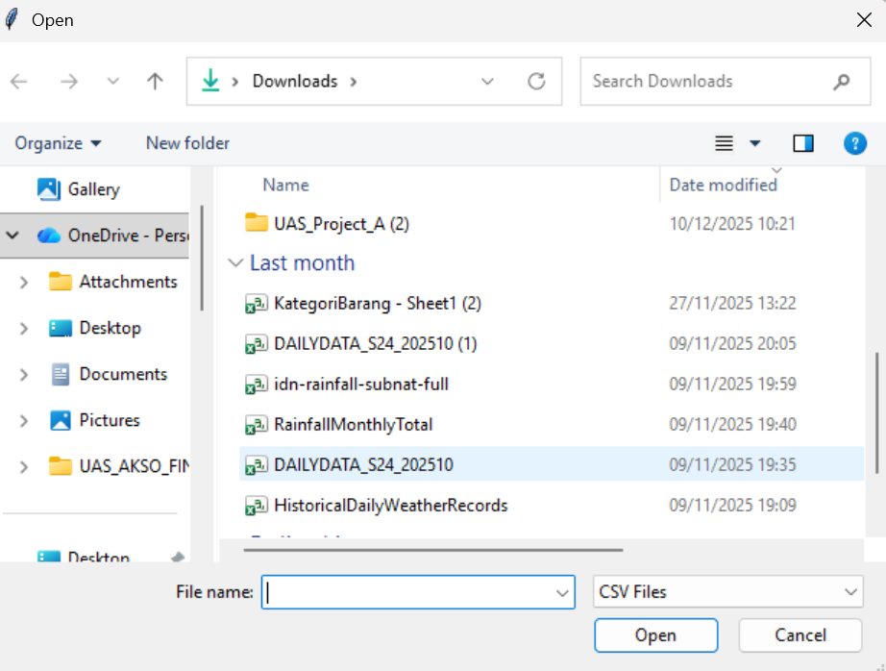
File browser dialog for selecting CSV files to import products.

3.3 KEY FEATURES SUMMARY
The Minimarket Cashier System successfully implements the following features:
- Welcome Screen: Professional entry point with tutorial access
- Product Management (CRUD): Complete create, read, update, delete operations
- Search Functionality: Real-time filtering by SKU or name
- Shopping Cart: Add, remove, update, clear with quantity management
- Checkout Process: Tax calculation, transaction recording, stock updates
- Receipt System: Text generation, file saving, GUI preview
- CSV Import: Bulk product addition from external files
- Data Persistence: SQLite database with normalized schema
Technical Achievements:
- Object-Oriented Programming with class inheritance
- Normalized database design with foreign key relationships
- Input validation and error handling
- Event-driven GUI programming
- File I/O operations
- Dynamic UI updates through variable binding

CHAPTER 4
ATTACHMENT

4.1Embed File
Embed below is the full code of Minimarket Chasier System.
Minimarket Chasier System

REFERENCES
Novitasari, Ridwan Zulfi Agha, Nedsal Sixpria, and Atyanto Mahatmyo. 2023. “Pemanfaatan Sistem Informasi Akuntansi Digital Si Apik Untuk Menghasilkan Laporan Keuangan Umkm Yang Berkualitas.” Prosiding Seminar Nasional Pengabdian Kepada Masyarakat4(1).
Tuerah, Raykes Hinrich, Meike Negawati Kesek, Deisi Elisabeth Malonda, and Ruhiyat. 2022. “Penerapan Penyusunan Laporan Keuangan Usaha Mikro Kecil Dan Menengah Berbasis SAK EMKM (Studi Kasus Usaha Cuci Mobil Toms Car Wash Di Desa Tombatu).” Jurnal Kewarganegaraan6(2):4542–48.
Binuko Paksi, A., Hafidhoh, ul, & Kariagil Bimonugroho, S. (2023). Perbandingan Model Pengembangan Perangkat Lunak Untuk Proyek Tugas Akhir Program Vokasi Program Studi D3 Teknologi Informasi, Politeknik Negeri Madiun (Vol. 14).

